# Retail Sales Dashboard 2023 – Workflow

Author: Samuel Čižik

**1. Uploading the Retail Sales Dataset from Kaggle into Excel and cleaning the data in Power Query**

- Verified data types

- Filtered records to include only the year 2023 (removed 2024 entries)

**2. Added the Age Category column in Excel**

**3. Creating Pivot Tables**

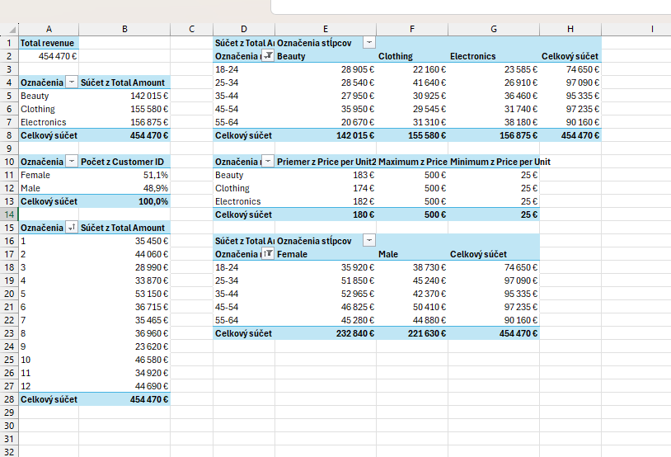

**4. Creation of an interactive dashboard with filtering options by gender, month, product category, and age group. The dashboard displays:**

- Total revenues

- Gender distribution

- Revenues by category

- Monthly revenue trends

- Revenues by age group and product type

- Summary statistics (average, maximum, minimum revenue per unit)

**5. Dashboard visualization with filtering examples:**

**Obrázok, na ktorom je text, snímka obrazovky, písmo, číslo

Obsah vygenerovaný pomocou AI môže byť nesprávny.**

